**THE PATENTS ACT. 1970**

**COMPLETE SPECIFICATIONSECTION10**

**TITLE**

**“MODERN BARRIER”**

# APPLICANT

S. Elango – Assistant Professor, Department of ECE, Bannari Amman Institute of Technology, Sathyamangalam, Erode, Tamil Nadu 638401, An Indian National

A. Stephen Sagayaraj- Assistant Professor, Department of ECE, Bannari Amman Institute of Technology, Sathyamangalam, Erode, Tamil Nadu 638401, An Indian National

R.S. Kaviya – Student, Department of ECE, Bannari Amman Institute of Technology, Sathyamangalam, Erode, Tamil Nadu 638401, An Indian National

S. Poorvasanthiya– Student, Department of ECE, Bannari Amman Institute of Technology, Sathyamangalam, Erode, Tamil Nadu 638401, An Indian National

P. Karanraj- Student, Department of EEE, Bannari Amman Institute of Technology, Sathyamangalam, Erode, Tamil Nadu 638401, An Indian National

T. Sneha- Student, Department of ECE, Bannari Amman Institute of Technology, Sathyamangalam, Erode, Tamil Nadu 638401, An Indian National

M.Mosikaran - Student, Department of ECE, Bannari Amman Institute of Technology, Sathyamangalam, Erode, Tamil Nadu 638401, An Indian National

S.Jeya Preethi– Student, Department of ECE, Bannari Amman Institute of Technology, Sathyamangalam, Erode, Tamil Nadu 638401, An Indian National

The following specification mainly describes the invention and the manner in which it is to be performed.

**MODERN BARRIER**

**Field of invention:**

The present disclosure relates to the low-cost mask that automatically detects the human temperature indicated through the LED. It comprises a SMD operational amplifier, battery and SMD thermistor where op-amp plays a significant role. The thermistor continuously measures the temperature when the mask is in use.

**Background of the invention & prior art:**

Nowadays, the mask is used widely because of the COVID -19 pandemic situation. The patent discloses a thermistor, which helps us measure the temperature automatically when it is used. Due to this invention, we can avoid the removal of masks in public places and avoid contact with the person who checks the temperature of all people in that particular place.

* Op-amp, with the help of the reference voltage, gives the output in the form of LED.
* The LED indicates the abnormal body temperature through a glow.
* Three major features of the mask are: it’s low cost, thin in structure and lightweight.

**Additional features of mask:**

1. Low-cost Mask
2. Low-power mask
3. Automatic ON and OFF of battery
4. Very thin structure
5. Light Weight
6. Mask integrated with circuit and inbuilt indicator

**Description of the prior art:**

The invention disclosed in CN111623881A involves block chain technology and image processing. The invention identifies the effect of temperature by using a double optical camera which is at low cost. This survey stands as a difference our invention doesn’t include any of their technologies both inventions have automatic detection of temperature in common.

The invention disclosed in KR20200141010A measures the change in temperature by being in contact with face, thereby enabling confirmation of infection symptoms such as COVID19 in a place where people gather. The survey includes thermo chromic structure whereas ours

include simple thermistor. But both the inventions indicate the temperature using LED.

The invention disclosed in CN111838813A measures the temperature using infrared temperature measurement module, an ultraviolet disinfection module, and displays it using an information display module and a wireless communication module. The information display module is used for displaying the current body temperature of the mask users. Our project doesn’t involve temperature measurement.

The invention disclosed in CN211904417U indicates the temperature by using a display panel, image acquisition module, body temperature detecting module and voice broadcast module. The facial image that the camera captured was sent to the discernment verification module. That contains an image recognition unit and a body temperature verification unit.

Both the invention helps in automatic detection of temperature by two different methods.

The invention disclosed in KR102242056B1 checks the body temperature status by changing the color. In the case of infectious disease, that transmission rate is lower and when worn by the elders and children who cannot grasp the risk of body temperature by themselves. This involves discoloration.

**Brief Description of the Drawing:**

Figure 1 – Breadboard connection with LED output

Figure 2 - Circuit diagram in schematic form, PCB layout and fabrication of IC

Figure 3 – Circuit using SMD components

Figure 4 – Mask diagram

**Detailed description:**

The invention consists of 4 parts:

1. Operational amplifier
2. Thermistor
3. Coin sized battery
4. LED
5. Reference voltage
6. Op-amp is the body of the circuit. The op-amp, with the help of reference voltage& thermistor, gives the output in the form of LED.
7. A thermistor is a resistance thermometer or a resistor whose resistance independent on temperature. The term is a combination of thermal and resistor.
8. A button cell, watch battery, or coin battery is a small single-cell battery shaped as a squat cylinder typically 5 to 25 mm (0.197 to 0.984 in) in diameter and 1 to 6 mm (0.039 to 0.236 in) high — resembling a button.
9. LED gives the output in the form of color. The LED glows when abnormal temperature is detected and doesn’t glow in normal conditions.
10. Reference voltage: A voltage reference is an electronic device that ideally produces a fixed (constant) voltage irrespective of the loading on the device, power supply variations, temperature changes, and the passage of time. The values are measured and given. If the value exceeds, the LED indicates an abnormal temperature; else it indicates a normal temperature.
11. The cost of Integrated Circuit is ₹10, Thermistor is ₹10, Overall circuit is ₹10, Ordinary mask is ₹10. So the total cost of our modern barrier is ₹40.

**Calculation:**

| **Resistor** |  | **Value** | **Temperature** |
| --- | --- | --- | --- |
| R1 | 2k |  |  |
| R2 | 3k | | 28° |
| R3 | 3.5k | |  |
| R1 | 1.5k | |  |
| R2 | 3.5k | | 39° |
| R3 | 2.5k | |  |
| R1 | 1.6k | |  |
| R2 | 3.4k | | 39° |
| R3 | 2.5k | |  |
| R1 | 10K | |  |
| R2 | 15K | | 38° |
| R3 | 39K | |  |

**Claims:**

We claim,

.

| [claim 1] | A smart mask that indicates normal and abnormal temperature using a thermistor which is in contact with the skin and the output is indicated through LED. |
| --- | --- |
| [claim 2] | The method of claim 1, wherein a mask that measures temperature automatically. |
| [claim 3] | The method of claim 1, wherein a thermistor, a LED, a coin sized battery and resistors are connected to an operational amplifier to detect temperature. |
| [claim 4] | The method of claim 1, as the resistor values that are connected in parallel to the thermistor decreases when the temperature increases. |
| [claim 5] | The method of claim 1, wherein the LED that is shown outside will glow when the temperature is above normal value (i.e) 37° C |

**Abstract:**

One of the most crucial protective measures against Covid-19 is face masks. Wearing a face mask can protect people from the spread of Viruses and Risks of infection. In Public places like Airports, hospital masks are of high use. People will be tested on temperature and Pulse rate in Public places To avoid the Entry of people with abnormal temperatures and provide Emergency treatment to those who are tested on temperature and Pulse rate frequently. This involves the use of a Pulse oximeter and an Infrared Thermometer. Usage of the same devices to all members may bring the chances of Virus spread. In recent days, masks have been designed to various types with much advancement. This invention which consists of thermistor, Op-Amp, LED is designed in such a way that the temperature is detected automatically. LED gives the output in red and green colors which indicates normal and abnormal temperature respectively. This mask which is of low cost is used to detect temperature automatically and its of great use in Public areas during Pandemic times

| S Elango  A.Stephen Sagayaraj  R S Kaviya | No. of sheets: 4 |
| --- | --- |
| S Poorvasanthiya  P Karanraj  M Mosikaran  T Sneha  S Jeyapreethi | Sheet No 1 |

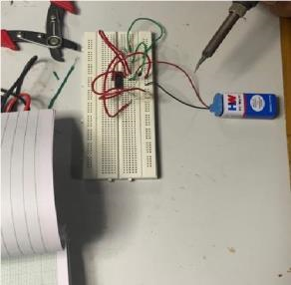

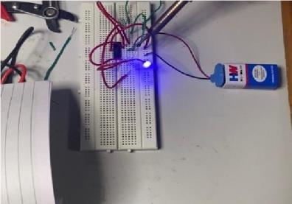

FIGURE 1

BREADBOARD CONNECTION WITH LED OUTPUT

| S Elango  A.Stephen Sagayaraj  R S Kaviya | No. of sheets: 4 |
| --- | --- |
| S Poorvasanthiya  P Karanraj  M Mosikaran  T Sneha  S Jeyapreethi | Sheet No 2 |

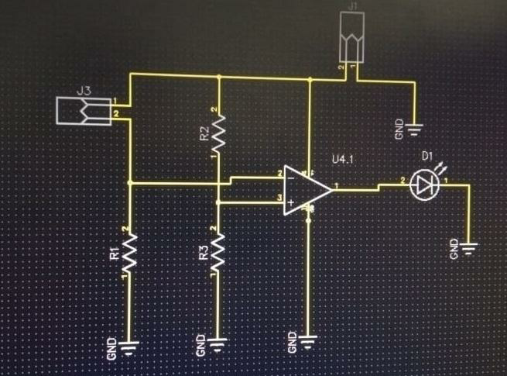 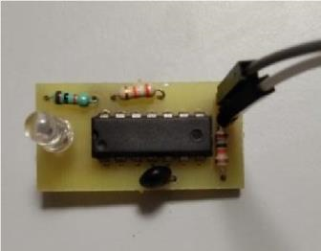

FIGURE 1

PCB DESIGN AND FABRICATION (THROUGH HOLE)

| S Elango  A.Stephen Sagayaraj  R S Kaviya | No. of sheets: 4 |
| --- | --- |
| S Poorvasanthiya  P Karanraj  M Mosikaran  T Sneha  S Jeyapreethi | Sheet No 3 |

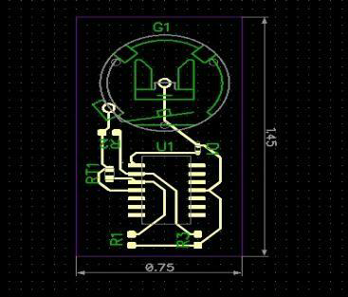

FIGURE 3 PCB LAYOUT (SMD COMPONENTS)

CIRCUIT USING SMD COMPONENTS

| S Elango  A.Stephen Sagayaraj  R S Kaviya | No. of sheets: 4 |
| --- | --- |
| S Poorvasanthiya  P Karanraj  M Mosikaran  T Sneha  S Jeyapreethi | Sheet No 4 |
|  |  |

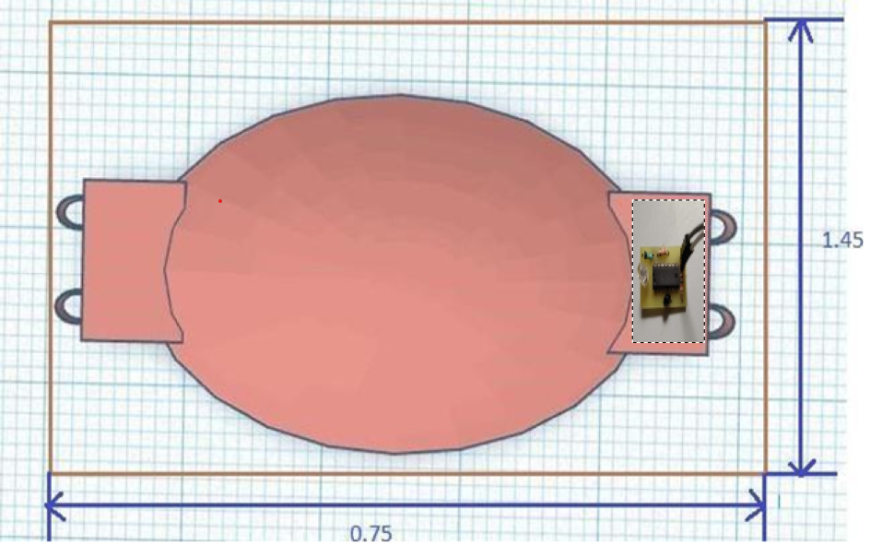

FIGURE 4

MODERN BARRIER (MASK)